

HOME BUILT

MODEL ROCKET ENGINES

by
Gary Jacobs

Copyright © 1979 by Product Engineering and Development Company. All rights reserved. No part of this book may be reproduced in any form without permission in writing from the publisher. Printed in USA.
CONTENTS

IMPORTANT NOTICE . . . . . . . . . . . . . . . . . . . . . . . . . . . . . . . . . 1
INTRODUCTION . . . . . . . . . . . . . . . . . . . . . . . . . . . . . . . . . . . . 2
SAFETY CODE FOR LOADING SOLID PROPELLANT ROCKET ENGINES . . . . . 4
NAR-HIAA MODEL ROCKET SAFETY CODE . . . . . . . . . . . . . . . . . . . . . 5
THE ROCKET ENGINE . . . . . . . . . . . . . . . . . . . . . . . . . . . . . . . . . 7
PROPELLANT . . . . . . . . . . . . . . . . . . . . . . . . . . . . . . . . . . . . . . 9
ENGINE CASING . . . . . . . . . . . . . . . . . . . . . . . . . . . . . . . . . . . . . 15
THE MOLD . . . . . . . . . . . . . . . . . . . . . . . . . . . . . . . . . . . . . . . . 20
LOADING THE ENGINE . . . . . . . . . . . . . . . . . . . . . . . . . . . . . . . . . 26
USING THE ENGINES IN ROCKETS . . . . . . . . . . . . . . . . . . . . . . . . . . 31
APPENDIX I - DIMENSION CHART . . . . . . . . . . . . . . . . . . . . . . . . . . . 32
APPENDIX II - ENGINE PERFORMANCE AND COST . . . . . . . . . . . . . . . . . . 33
APPENDIX III - A HOME MADE BALANCE . . . . . . . . . . . . . . . . . . . . . . . 34
APPENDIX IV - TROUBLE SHOOTING HINTS . . . . . . . . . . . . . . . . . . . . . . 35
REFERENCES . . . . . . . . . . . . . . . . . . . . . . . . . . . . . . . . . . . . . . 39
REVISED TECHNIQUES . . . . . . . . . . . . . . . . . . . . . . . . . . . . . . . . . 41

IMPORTANT NOTICE

The information contained in this text is intended for the serious experimenter and should be used only by those with a thorough background knowledge in model rocketry. Commercially manufactured model rocket engines and model rocket kits are readily available and should be used by beginners. Model rocket engines built by the amateur from this text must be made very carefully and by following all safety standards explicitly to be effective, reliable and safe. In addition to the rules listed for the construction of rocket engines, the NAR safety rules for model rocketry should also be adhered to.
Basement bombers of an earlier era gave amateur rocketry a bad name before the advent of commercial model rocket engines and the National Association of Rocketry which developed standards for the industry and sport. The author urges you to help maintain amateur rocketry’s good name by using common sense and following all safety rules.
The building and launching of home built rocket engines comes under the classification of experimental amateur rocketry and not under model rocketry. Consult your state fire marshal as to the laws and regulations in your state as a special license may be required. They will be glad to help you obtain a license or find someone who already has one to supervise your activities.
Product Engineering and Development Company (PEADCO) shall not be liable for any damages or injuries resulting from activities or experimentation carried on as a result of information contained within this manual because we have no control over the use of this information.

INTRODUCTION

For those people who do not have a background in rocketry or who want maximum performance and efficiency from a rocket engine, I strongly recommend commercially manufactured model rocket engines. In no way can you expect to make at home with a minimum of equipment and by hand the same quality of product achieved with hundreds of thousands of dollars worth of mechanical equipment and dozens of years of background knowledge and specialized training. The methods and procedures explained in this text borrow for the most part procedures used by ancient artificers hundreds of years ago coupled with some modern techniques and materials. Even some of the old techniques cannot be duplicated in a small home workshop but other techniques have been developed to compensate for this as will be explained later.
So, you say, why bother with constructing engines at home? Several reasons. Nothing can match the pride and excitement of watching something you have built yourself do the job it was built to do. Watching a rocket lift off the launch pad, streak skyward nearly out of sight and return to earth again swaying gently from it's parachute in perfect condition to fly again is something that must be experienced. When that rocket has been built 100% “from scratch” including the engine, it is an accomplishment shared by very few other people in the entire nation.
Besides the pride of accomplishment, there are infinite variations of sizes and powers of engines that can be built. Engines can be produced having nearly any shape thrust time curve. Large engines, very small engines, or any size of standard or sizes between standards can be built. The field is wide open for experimentation, not only to find how to make an engine perform just as you want it to but in methods of construction, materials and tools for construction and simple machines to facilitate construction.
Although this text will give explicit details for constructing engines, it is the hope of the author that it will also motivate and challenge you to go beyond merely following instructions and delve into this field in true scientific curiosity. Try to improve on the ideas presented and search out that “better way” of doing it. This curiosity backed by training and knowledge has been the backbone of our modern technology.

Curiosity by itself is not enough. To truly advance technology a thorough knowledge of the technology existing is also necessary. I again urge you, if you do not have a background in model rocketry start with commercial engines and read everything you can find on rocketry. A list of books, publications, and suppliers is listed at the back of the book.
SAFETY CODE

For Loading Solid Propellant Rocket Engines

- Never use any metallic components in the construction of the engines.
- Never use steel against steel in any operation involving propellant. If a steel piercer is used, wood, brass, or aluminum loading dowels must be used. All sparks must be avoided.
- Never attempt to produce or use propellant using components other than sulfur, charcoal, and saltpeter. Chlorate mixtures are expressly forbidden. They are unstable and unpredictable.
- Propellant should be made and stored in quantities no greater than eight ounces and should be stored in non-breakable plastic containers.
- Any drying methods used for propellant or loaded engines must not have exposed flames or exposed high temperature surfaces. (Such as heating elements or light bulbs)
- All engines, propellant, and chemical components must be stored under lock and key away from children.
- Any new engine configuration is to be tested on a static stand in seclusion. Engines are to be tested vertically in case a nozzle or top heading is expelled.
- All engines and rockets are to be tested or launched by electrical ignition from a distance of 20 feet for I.Ds of 5/8” and smaller, 30 feet for larger engines.
- Since all homemade engines are considered experimental, they cannot be launched in public or for demonstrations.

NAR-HIAA MODEL ROCKET SAFETY CODE

- Construction--My model rockets will be made of lightweight materials such as paper wood, plastic, and rubber without any metal as structural parts.
- Engines--I will use only preloaded factory-made model rocket engines in the manner recommended by the manufacturer. I will not change in any way nor attempt to reload these engines.
- Recovery--I will always use recovery systems in my model rockets that will return them safely to the ground so that they may be flown again.
- Weight limits--My model rocket will weigh no more than 453 grams (16 ounces) at lift off, and the engines will contain no more than 113 grams (4 ounces) of propellant.
- Stability--I will check the stability of my model rockets before their first flight, except when launching models of already proven stability.
- Launching system--The system I use to launch my model rockets must be remotely controlled and electrically operated, and will contain a switch that will return to "off" when released. I will remain at least 15 feet away from any rocket that is being launched.
- Launch safety--I will not let anyone approach a model rocket on a launcher until I have made sure that either the safety interlock key has been removed or the battery has been disconnected from my launcher.
- Flying conditions--I will not launch my model rockets in high winds, near buildings, power lines, tall trees, low flying aircraft, or under any conditions that might be dangerous to people or property.
- Launch area--My model rockets will always be launched from a cleared area, free of any easy to burn materials, and I will use only non-flammable recovery wadding in my rockets.
- Jet deflector--My launcher will have a jet deflector device to prevent the engine exhaust from hitting the ground directly.
- Launch rod--To prevent accidental eye injury, I will always place the launcher so .the end of the rod is above eye level, or cap the end of the rod with my hand when approaching it. I will never place my head or body over the launching rod. When my launcher is not in use, I will always store it so that the launch rod is not in an upright position.
- Power lines--I will never attempt to recover my model rocket from a power line or other dangerous place.
- Launch targets and angle--I will not launch rockets so their flight path will carry them against targets on the ground, and will never use an explosive warhead nor payload that is intended to be flammable. My launching device will always be pointed within 30 degrees of vertical.
- Prelaunch test--When conducting research activities with unproven designs or methods, I will, when possible, determine their reliability through prelaunch tests. I will conduct launchings of unproven designs in complete isolation.
THE ROCKET ENGINE

The home constructed rocket engine is very similar to commercial engines but also there are some important differences. Refer to Figure 1. The propellant is ignited through the nozzle and burns on the entire inside surface of the core. The burning produces hot gases under pressure which then are forced through the nozzle at a high velocity to produce thrust. These engines are called core burning as opposed to port or end burning engines. The large core burns evenly outward toward the case. The portion of propellant above the top of the core is thicker than the thickest portion of propellant around the core. When the propellant around the core is expended, the pressure drops and the time it takes to finish burning the top portion to the clay heading is equivalent to the delay charge in commercial model rocket engines.
(see Figure 2) As the last of the propellant burns, it ignites the ejection charge through the clay heading and ejects the rocket recovery system. The delay allows time for the rocket to coast to the maximum altitude.
The propellant used in the home constructed engine is not as powerful as commercial fuel and burns slower so the large burning area of the core burning engine is needed to obtain enough thrust. The reasons will be explained in the propellant section. Specific impulse is a measurement of propellant efficiency and is determined by dividing the total impulse of the engine by the weight of the propellant. Most commercial model rocket engines have specific impulses between 50 and 100 seconds. Large professional solid propellant engines commonly have specific impulses of 180 to 250 seconds. The home constructed engine normally has a specific impulse of 20 to 50 seconds.
In earlier engines the case was choked to restrict the exhaust gases and form a nozzle (see Figure 3). This was done by tying string around the bottom while the case was still wet. These engines burned the paper in the nozzle and so enlarged it as the fuel was consumed and the pressure and thrust dropped off prematurely. The specific impulse of these engines were even smaller yet.
The clay heading is needed to contain the pressure, as the method used to compress the propellant charge is not adequate in itself to contain the pressure of the exhaust gases. Also the commercial gunpowder used for the ejection charge, to work properly, cannot be compressed and so cannot be placed between the clay heading and propellant. It is held loosely in place by the paper retainer.
The case is made from paper for the same reasons as commercial engines. It is strong, fire-resistant, does not conduct heat readily, and if it should burst, light weight harmless paper shreds are the only product.
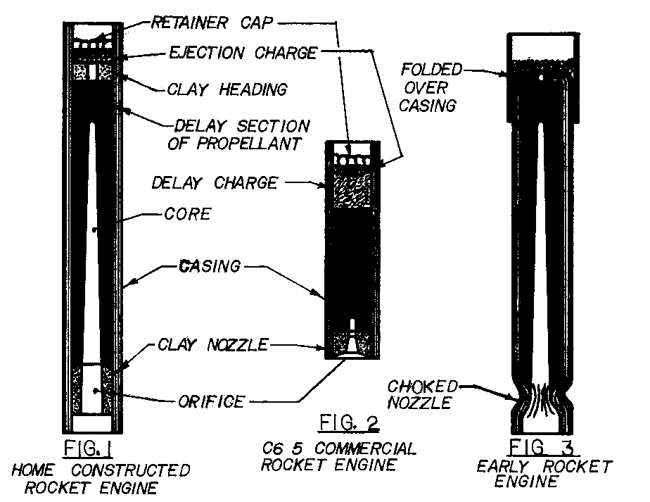
PROPELLANT

Homemade black powder is used for propellant. It is made from a mixture of potassium nitrate (saltpeter), charcoal (carbon), and sulfur. Commercial black powder is made from a composition of 75% potassium nitrate, 12.5% to 15% charcoal and 10% to 12.5% sulfur. It has been found that any significant deviation from these proportions produce powder that burns more slowly and leaves more residue. The purity, source of chemicals, how finely powdered, amount of moisture present, and the degree of intimacy to which the chemicals are mixed will affect the potency of the powder.
Commercial black powder is prepared in several steps. First the chemicals are mixed together with a small amount of water. Next the mixture goes to the incorporating mill. A stamp mill works vertically pounding the powder in a hollow cavity cut in a slab of granite. A cylindrical section of wood is used to pound the powder. The action is very similar to that of a mortar and pestle.
The wheel mill uses huge granite wheels weighing 8 to 10 tons and rather than pound the powder, they roll it. Much heat is produced in this process and so water is continually added to replace what is evaporated. The powder is kept just moist enough to prevent dust from forming.
This incorporating is the most important part of the process. It mixes the constituents much more intimately than the mechanical mixing process. The powder is then pressed into cakes in a hydraulic press.
Corning or granulating, which is the next step, is the most dangerous. The cakes are crushed and granulated between rollers to form it into particles. The dust created from this process is called meal powder and is the most violent form of black powder and is coveted by fireworks manufacturers. The particles are then rounded, polished, glazed and graded for size.
The grain size controls the speed of burning because it determines the surface area exposed to the flame. The larger the grain sizes the smaller the surface area per given volume of powder there is, and so the longer the burning time is. It takes longer to burn through to the center of the grain. When black powder was used in fire arms, larger grain sizes were used in larger guns so the expanding gases which ejected the projectile would not build up pressure faster than the projectile could be accelerated. Many improvements were made in producing the grains to give more surface area so the powder would burn more rapidly. Special molds were developed that produced hollow hexagonal grains. The outside surface area decreased as it burned but the inside surface area increased so the grain was consumed very rapidly. The special shapes were produced to give high surface area per volume of powder but still have a large percentage of open spaces in and between the grains for the fire to be communicated.
Smaller grain sizes burn more rapidly to a point and then because of decreased voids between grains, they burn progressively slower as the size decreases. Burning is initiated on one surface and is unable to propagate further so burns only at the surface of the pile and burns progressively through the pile as the surface is consumed. In larger grains the fire is spread throughout the pile through the spaces between grains and so nearly the entire pile can be burning at one time. This burning can be so rapid as to be nearly explosive.
In solid propellant rocket engines, the powder is, pressed into the case with a long core. The fuel essentially is one large grain formed by compacting the powder under considerable force. When the fuel is ignited, fire is communicated almost instantly up into the core so the entire inside surface is ignited and the fuel burns towards the outside wall. As it burns the surface area increases and so does the thrust. The thrust starts out low, builds up to a maximum and then drops to zero as the fuel is used up. (See Figure 4) This is the opposite of what would be desired. What is needed is a high initial thrust to quickly accelerate the rocket to a speed where the fins can stabilize it and then drop to a lower sustaining thrust to accelerate the rocket to its maximum speed. This is very difficult to achieve with a core-burning rocket but the thrust curve can be improved by using a tapered core. The fuel is used up at the bottom of the taper first and then the burning continues in a fairly uniform conical shape towards the top of the rocket. (See Figure 5) Just keep in mind that the thrust of an engine at any instant is in direct proportion to the surface area burning at that instant.
When preparing black powder at home, normally nothing beyond a standard chemistry lab mortar and pestle is within the means of the experimenter so powder equal in quality to that of commercial powder is quite impossible to achieve. If prepared properly, however, powder of considerable vitality is possible.

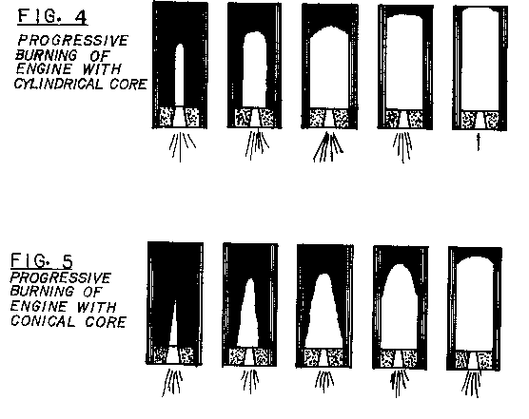
All three chemicals can be obtained by mail from laboratory supply companies and of course the larger quantities are less expensive. The lowest purity grade is quite sufficient. The finest particle size available should be used especially for the charcoal. Charcoal available as "dust-air floated" is the best. Saltpeter and sulfur is usually available in most any drug stores, too, but the price is very high. This is often the source used to get started until supplies from other places are obtained.
The cheapest form of potassium nitrate is fertilizer grade. Potassium nitrate is available as fertilizer in 50 or 100 pound bags and can often be found in smaller quantities in garden shops. Potassium nitrate is also available in bulk form as fertilizer and a person may be able to make a deal for a small quantity as a favor. The fertilizer grade is either in granular form or a coarse mesh powder. The granular must be crushed in a mortar and pestle. The coarse powder can be screened through a fine screen to take out the lumps and then used as is. It will dissolve in the water in mixing if done thoroughly.
Sulfur is also used to some extent in agriculture and might be available in garden shops but it might be the most difficult item to obtain at a reasonable cost even though value-wise it should be cheaper than saltpeter. Since it comprises only 10-13% of the total mixture, drugstore or mail order supplies might be acceptable if another supply cannot be easily located.
Charcoal can be made if a little extra work is not too objectionable. The source and degree to which it is pulverized will make the most difference in the performance of the finished powder. There are some differences in the impurities present and quality of the charcoal that comes from different types of wood. Any charcoal can be pulverized and used but it should first be filtered through a piece of silk cloth such as is used on model airplanes. A nylon stocking is not sufficient. The holes are too large and vary depending on how much it is stretched. One method that is fairly quick and easy is to use charcoal briquettes and an old blender or Osterizer. The briquettes are first put in a piece of canvas preferably or a piece of old denim (which gets holes too easily) and pounded with a wooden or plastic mallet on a concrete walk or floor until they are broken in small pieces. The charcoal can then be put through a quarter inch mesh hardware cloth. What does not go through should be re-pounded. The rest can be put in an old blender on high speed for several minutes. Don't use a good blender because the charcoal dulls and erodes away the blades quite rapidly. If the motor is lugged or the speed changes, there is too much load on the motor and it could be burned out quickly. Remove some of the charcoal and try again. Let the blender set a few minutes after it is shut off to let the dust settle. The charcoal dust is very messy and will cover everything so this is a good outside job. A good way to separate the dust is to use a large coffee can with a plastic lid. Cut the top of the lid out leaving the edge and about a quarter inch ring. Use this to hold a piece of silk on the can. Dump the charcoal out of the blender into the coffee can and secure the silk to it with the plastic ring or string, wire or large rubber bands. The best way I found to collect the dust without getting it all over is to use a large plastic bag or a dry cleaners bag tied at one end. The plastic bag is held tightly to the silk end of the coffee can and the dust shaken into the bag. The dust can then be transferred to another container with a lid. What didn't go through the filter can be returned to the blender. The dust thus obtained is very fine and works extremely well in gunpowder. The charcoal must be as fine as dust to make good powder. This is the main key in the manufacturing process at home.
A composition of 68% saltpeter, 22% charcoal, 12% sulfur has been found to work well with charcoal obtained from charcoal briquettes. This could possibly be because there are binders or other impurities in the charcoal or possibly for some other reason. It is important that you experiment with small quantities of different compositions to find what works best with the particular chemicals you are using. Start with the 75-15-10 combination of potassium nitrate, charcoal and sulfur, respectively, and compare other mixtures to it. Use small identical quantities and ignite them one at a time. Compare the effect. The test should be done on a clean flat surface. A good powder should produce few "pearls" or small balls of residue on the surface after the burn. Make sure that you use the same weight each time, each composition has the same percentage of water by weight, and the shape of the pile is about the same. Too much water in the powder will slow the burning rate and cause more pearls to result.
All mixing proportions are by weight. This is the only way to get consistent accurate measures. Some form of balance is a necessity. 1% of the weight being weighed is a sufficient degree of accuracy. A homemade balance is described later if a purchased one is not available. However, this is one item that I consider a worthwhile investment if this or similar activities are to be pursued to any extent.
To prepare the black powder, the potassium nitrate must be pulverized in a mortar and pestle if it is in granular form or lumpy. Sift it through a fine mesh screen (finer than ordinary window screen) and then weigh out the proper portion and put it in a glass, plastic, or stainless steel bowl. Weigh the proper portion of sulfur being sure to deduct the weight of the weighing container. Take a portion of your weighed and screened saltpeter and mix it up thoroughly with the sulfur and pass the mixture through the screen once more. Mixing the two together before screening the sulfur will prevent the sulfur from recaking after screening before they are mixed and will prevent unmixed sulfur pockets. Rub through the screen any sulfur lumps that did not pass through. Mix all the saltpeter and sulfur thoroughly. Now very carefully spoon out and weigh the proper amount of charcoal dust. If it is handled and mixed slowly it will not fly around too much. Mix all three ingredients very thoroughly. Passing them all through a screen once or twice more will help break up pockets of unmixed chemicals. Finally, weigh out about 3% to 5% the total powder weight of water and mix into the powder. This will seem like a very small amount of water for the amount of powder but it does not take much to moisten it. The mixture should now be worked thoroughly--the more the better. Repeatedly mashing the powder against the side of the bowl with an old spoon and working the water evenly into the powder is the operation that takes the place of the commercial incorporating mill. You don't have to spend hours doing this but several minutes would be very beneficial. To most effectively test the powder, it should be dry. It can be passed once more through a screen to fluff it up before setting it aside to dry. A thermostatically controlled food dehydrator can speed the process if you are in a hurry. If you are going to load the powder in rocket engines, it must be done while still moist or if dry, must be remoistened with 3%-5% water. If it is to be stored before being loaded, the powder should be dried first and then stored in an airtight plastic container.
ENGINE CASING

The engine casings are made by rolling a good quality paper brushed with glue around a mandrel. Butcher paper and shelf paper are good sources of good quality inexpensive paper. The paper should be as dense and nonporous as possible. Paper like newsprint is not strong enough. Also, the thicker the paper is the easier it will be to roll a tight case. White glue such as Elmers® is used to produce a good solid tube when wound tightly.
Wooden dowels are available from 1/16 inch to 1 inch in diameter and are moderately inexpensive, so are used as a standard size for the inside diameter (I.D.). All other dimensions are based on this dimension. The proper size dowel is chosen for the size engine desired and a piece is cut off about 4 or 5 inches longer than the tube length. This will serve as the rolling mandrel.
Next, strips of paper are cut that are as wide as the engine will be long. Shorter strips 12 to 18 inches long are easier to work with. Strips can be cut accurately and very rapidly from a roll of paper if a cutting board of plywood, particleboard, Masonite®, etc. with guidelines are used. (See Figure 6) The paper is pulled out to one guide line and then a straight edge is lined up with a second line and used to guide a hobby knife or sharp pocket knife to cut the strip.
It is much more efficient to cut strips for a large number of engine casings at one time so you will have a large supply to draw upon as you want them. If each process is done for a large number of engines at the same time, less total time will be required for the construction of each engine.
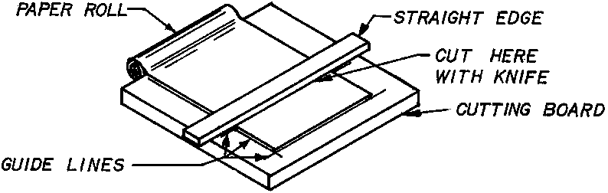
Figure 6
Before the cases are rolled, a plastic spacer must be cut. The same diameter dowel that is used to roll the casing on is used to compress the propellant in the casing later. The casing is wound very tightly on the spindle so the spacer performs two functions. First the plastic spacer is rolled tightly on the mandrel and then the paper is wound and glued to itself over the plastic. The plastic is slick and so allows the mandrel to be easily removed from the casing. This is not as easy if the paper is wound directly on the mandrel. Second, when the plastic spacer is removed from the case, the inside diameter is a few thousandths larger than the mandrel. When the propellant is then compressed into the case, the loading dowels can be easily removed.
The plastic spacer can be made from nearly any thin flexible plastic sheet. Four-mil polyethylene such as is used for storm windows will work well. The spacer should be cut about an inch wider than the rocket case is long. The length should be cut so that it will wrap between l½ and 2 times around the mandrel.
Cases should be rolled on a smooth flat working surface that is not harmed by water. A Formica covered tabletop will work fine. Do not use a wood tabletop. A 2½ to 3 foot square piece of plywood or Masonite painted with a plastic finish can also be used.
Before beginning rolling cases assemble all your supplies. You will need your working surface, paper strips, rolling mandrel, plastic spacer, a bowl of water, cleaning rag or old wash cloth, old towel or rag for drying, bowl of thinned glue and a small sponge.
The glue should be thin enough to spread easily on the paper and be soaked up by the sponge but not so thin that it soaks into the paper and dries before it can be rolled. It should be only thin enough to make it easy to work with. If it is too thin the finished dry case will be soft and flexible instead of hard and rigid. The sponge should be as wide as the paper to be glued when making smaller rockets but should not be more than three or four inches wide.
To roll the case, first roll the spacer tightly around the mandrel. Lay the plastic on your working surface. Lay the mandrel on the edge closest to you and roll the plastic onto the mandrel rolling it away from you. To help roll it tightly, a small piece of cellophane tape can be used in the middle of the plastic to hold the first edge in place on the mandrel. (See Figure 7) Next lay the paper on the working surface as you did with the plastic and begin rolling it over the plastic in the same direction. Do not use any tape on the paper. Be very careful at all times that the plastic and paper are tight. Loosely wrapped cases with air spaces will be weaker and will burst when the engines are loaded or fired. Make one half wrap of paper around the plastic and then spread glue along the first edge on the top surface. (See Figure 8) Then continue to roll the paper until this surface contacts the inside surface of the paper laying on the working surface. This step is very important and must be done very carefully and tightly. If this first wrap is not completely tight around the mandrel, it will be impossible to roll the remaining wraps tightly. There must be no glue between the paper and plastic surfaces or it will not be possible to remove the spacer without damaging the inside surface of the case. If the edge of the paper on the inside of the case is not glued securely it will wrinkle and tear when the engine is loaded. This will cause voids in the propellant that will cause the engine to malfunction.
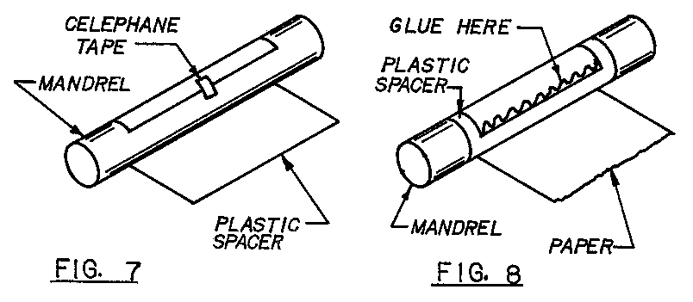
After the first wrap is made tightly, the remainder of the rolling is relatively easy and rapid. Spread glue over the remaining surface of the paper. Hold the far edge of the paper with one hand spreading the two corners and holding them in tension. Pull the roll stretching the paper lengthwise slightly and roll the paper. Stop and pull the roll once or twice more as you roll the paper. Pressing the case against the working surface as you roll it will also help roll it tightly. If the paper begins to roll crooked, press harder on the lagging side or stretch the leading side a little tighter to correct the situation. Be very careful to start rolling the paper straight and apply even pressure as you roll to keep it rolling straight. Trying to correct the direction of roll increases the possibility of air gaps and a loosely rolled end on the case. Rolling casings takes practice. Don't be discouraged if the first one or two come out less than perfect.
After glue is spread on the paper, it must be rolled very quickly to prevent wrinkles. It may help to spread glue on two or three sections one at a time and just roll it as far as the glue before spreading on the next section. For the second and all succeeding layers of paper, glue can be spread right up to the leading edge when starting that sheet. If when you finish rolling a sheet the last edge is not adhered well to the roll, either the glue is too thin or too much time was spent rolling the paper.
Continue to wrap successive layers of paper until the case has the proper outside diameter for the engine being built. (Consult the dimensions chart.) To remove the mandrel and plastic spacer, grasp the outside of the case and rotate the mandrel and plastic spacer the opposite direction from which it was rolled. This will loosen it and detach the tape if any was used. The mandrel and spacer should slide out together. If the mandrel comes out first the spacer can be removed by grasping an inside corner and twisting it in the opposite direction from what the case was rolled. This will roll the spacer into a smaller roll and pull it away from the inside of the case so it can be removed. You may have some glue on the surface of the plastic. This will have to be washed off and dried before rolling the next tube.
Your working surface will accumulate glue and must be washed off completely and dried occasionally. Usually three to six sheets can be rolled before they begin sticking to the working surface but it may have to be washed and dried after each sheet to start with. Be sure to wash out your sponge and rags thoroughly when you are finished before they have dried or the glue cannot be washed out at all.
When the cases are finished, they should dry partially before being loaded. The 1/4" and 3/8" can be dried completely but the larger casings should still be flexible and slightly moist to prevent internal splitting when they are loaded. This will also allow the nozzle clay to seat firmly in the casing.
A less efficient engine can be built by choking the case instead of using a clay nozzle. Choking is done as soon as the cases are rolled before the glue has dried. A "half ball” is made from a dowel the same diameter as the mandrel. A hole is drilled in the end of the dowel half it's diameter about two diameters deep. The end is sanded to a rounded shape and then cut off the end of the dowel. (See Figure 9) This is used to shape the nozzle end of the case.
A smaller dowel half the diameter of the mandrel is placed through the half ball and is used to control the nozzle orifice size. A length of twine is wrapped twice around the case about l½ diameters from the end and formed into the "artificers knot." (Clove hitch--see Figure 10) A long piece is used and tied around a stick at each end. One end is stood on and the other end is pulled by hand to squeeze the tube. The old artificers would secure the twine or cord to something firm like a hook on a wall, tie the other end to a stick, put it between their legs and lean back on it with their weight to choke the larger cases. The half ball is placed in the end of the case just below the twine loops and held in place. The orifice dowel is extended through the hole and into the case past the twine. The case is rotated as the twine is tightened so that the choking is accomplished as evenly as possible. The twine is then cut, the knot left on the case, the half ball and orifice dowel removed and the finished case set aside to dry.
It is a good idea to construct the mold before rolling the cases. The cases can then be placed in the mold and checked for a good fit. They should be larger than the mold bore so the mold lacks at least a sixteenth of an inch from closing on each side. If the cases are rolled the right size to begin with, it will eliminate the need for shimming it with additional paper later.
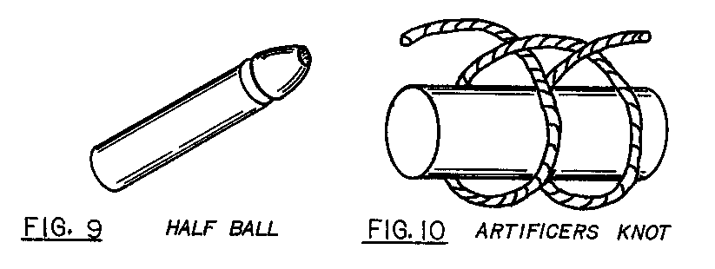
THE MOLD

Constructing the mold is probably the most difficult aspect of fabricating the rocket engine. It must be made relatively accurately to function properly and to accomplish this requires at least an accurate drill press and a metal lathe would be an enormous asset.
The mold accomplishes three things. It holds the engine casing securely in an upright position. The piercer forms the core in the engine that is necessary to give the engine sufficient thrust. The mold body contains the case against the large pressures applied to the case during loading and prevents it from bursting.
In addition to the mold, loading dowels must be constructed. These are merely dowels the same diameter as the rolling mandrel. They have holes drilled in them progressively smaller to be used successively in loading the engine. The smaller holes accept the smaller tapered portions of the piercer. Drilling the long straight holes accurately in the loading dowels and mold body is the task that presents the most difficulty.
Refer to Figure 11, 11a and 11b for the construction of the mold. The case is made from three pieces of standard 2x4 board. The base is six inches long. Refer to the dimensions chart (Appendix I) for the length of the body. Figure 11a gives all the hole placement specifications and other needed dimensions.
Cut the two body halves about two inches longer than the finished length allowing an inch on each side.
Cut a groove 1/16 inch deep and the width of the blade (1/8 inch) in the exact center of the mold halves. (See Figure 12) Line up these grooves on each end so that they form a square hole through the mold body when together. Temporarily nail the two halves together with the slots lined up. Trim both ends to the final length. Take great care to make these cuts absolutely perpendicular to the sides. If these cuts are not square it will be very difficult to drill the casing hole straight.
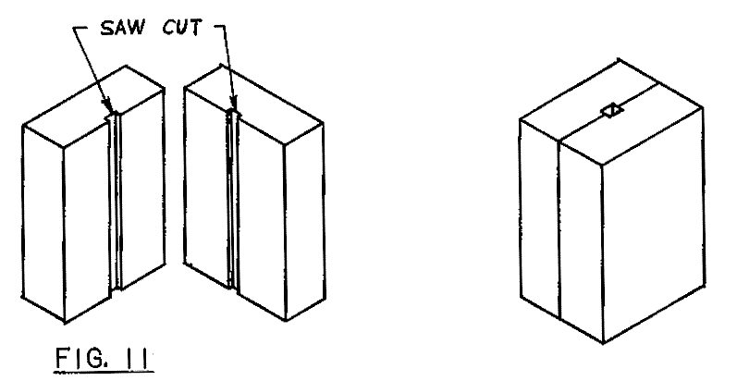

Drill the four quarter-inch holes on the sides through both halves. Use four quarter-inch by four inch long bolts to fasten the two halves together. Use flat washers on both sides or use carriage bolts and washers just beneath the wing nuts.
Bolt together the two halves of the body and tighten the wing nuts. Counter bore the two screw holes on the base and drill the pilot holes through. Center the base on the body with the counter bored holes away from the body and extend the pilot holes into the body. Now enlarge the pilot holes in the base to the screw clearance hole size and screw the base to the body.
Drill the casing hole using either wood boring bits or an expansive auger bit with a self-starting screw point. The tapered square shank end can be cut off so it can be used in a drill press. Take the mold apart a couple times and check to make sure the bit is still drilling straight. The drill should be stopped after the tip has entered the base but before the cutting blade cuts into the base. The last little piece of the body at the bottom of the hole can be cleaned out with a sharp knife.
For the taller molds, the expansive bit will not be able to reach the bottom. A machine shop can extend the shank for you or the remainder of the hole can be drilled with a wood boring bit and extension by hand, or by a longer auger bit and brace. It is easier to keep the bit straight after the main hole is drilled. Just keep the shank in the center of the top of the hole.
Remove the base from the body and drill an eighth inch or smaller pilot hole through the base where the auger bit tip drilled into it. Turn over the base and counter bore the piercer hole, then drill the piercer diameter hole through.
The piercer is most easily formed on a metal lathe. It should be made from steel ideally though experimental or temporary piercers can be made from wood and glued in place. The wood piercer can be easily formed by hand on a disk or belt sander but cannot be made very uniform. It can also be chucked in a drill press and then shaped using rasps and/or sanding blocks. The problem with wood piercers is that they break very easily, especially the smaller ones. Even with a coating of soap, a twisting motion will snap them off. The engine must be pulled straight off the spindle and if not securely glued into the base can be pulled out. Wood is porous and also compresses when the propellant is compacted. These factors make them adhere very tightly to the engine core. A considerable pressure is used to compress the propellant into the casing and it is sometimes necessary to stand on the base after removing the body and pull with considerable strength to separate the engine.

Metal piercers, however, generally are quite readily removed from the engine. The piercer could also be made from brass or aluminum. The piercer can be made from plain rod or from a long bolt with the head removed. The tapered section is turned on the unthreaded portion of the bolt. If plain rod is used, threads are cut on the opposite end or formed with a die. Normally, the small end of the taper is half the diameter of the large end but many specialized shapes can be tested to obtain different burn characteristics.
If a lathe is not available, the tapered piercer can be shaped by chucking it in a drill press and using a hand held power grinder or flat files. The files are very time consuming, though.
A washer is brazed onto the piercer just above the threads. It is imperative that the washer be exactly perpendicular to the threaded portion so the piercer will extend up through the exact center of the casing hole. The brazing should be done on the threaded side. A hole the diameter of the piercer can be drilled in a scrap of 2x4 and the piercer pushed through it upside down to hold it perpendicular. The washer can then rest on top of the board. Use additional washers under it for a heat sink. Rather than braze the washer on, the piercer can be threaded far enough to put a nut on the top of the base also. The nut must be counter sunk into the base so the top is even with the top of the base. Bolt the piercer in place using a flat washer and nut in the counter bored hole. Check to make sure when the mold is completely assembled that the top of the piercer is in the exact center of the bore in the body.
Other methods of attaching the piercer to the base can be used as long as it is positively secured and is aligned absolutely vertical and in the center of the casing hole in the mold body.
The nozzle spacer is made from a dowel the same diameter as the mandrel. Drill a hole the same diameter as the base of the piercer exactly centered in the dowel. Cut it off half as long as it's diameter. For the smallest molds, the spacer may have to be metal. Slide the spacer onto the piercer and the mold is complete.
The loading dowels are most easily made in a metal lathe. They can be placed in a three jaw chuck with some thin cardboard around them for protection and then drilled. This is really the only way to accurately center drill the holes.
Four loading dowels are made for each size engine. The first has a hole drilled the diameter of the base of the piercer and as long. The second dowel should be long enough to accept two-thirds the length of the piercer and have a hole diameter just large enough to accept the diameter of the piercer at that point. The third should accept only the top third of the piercer with a proportionately reduced hole diameter. The last dowel has no hole and is used to compress the last charges.
If no lathe is available, a length of 4x4 can be sawed square and have a hole drilled perpendicular to the bottom the size of the loading dowel. A base can then be attached to it, the dowel inserted in the hole, a nail used to secure the dowel, the dowel centered under the drill bit and the base clamped to the drill press table. If the base is not clamped the drill bit will invariably wander. If the drill bit is sharpened unevenly or if the grain in the dowel runs diagonally, the drill bit may wander anyway.
If the hole in the dowel is drilled crooked so the drill bit comes close to the outer surface of the dowel or comes out of it, the dowel will collapse in use and be ruined. If the hole is started off center it can force the piercer off center and cause the engine to malfunction.
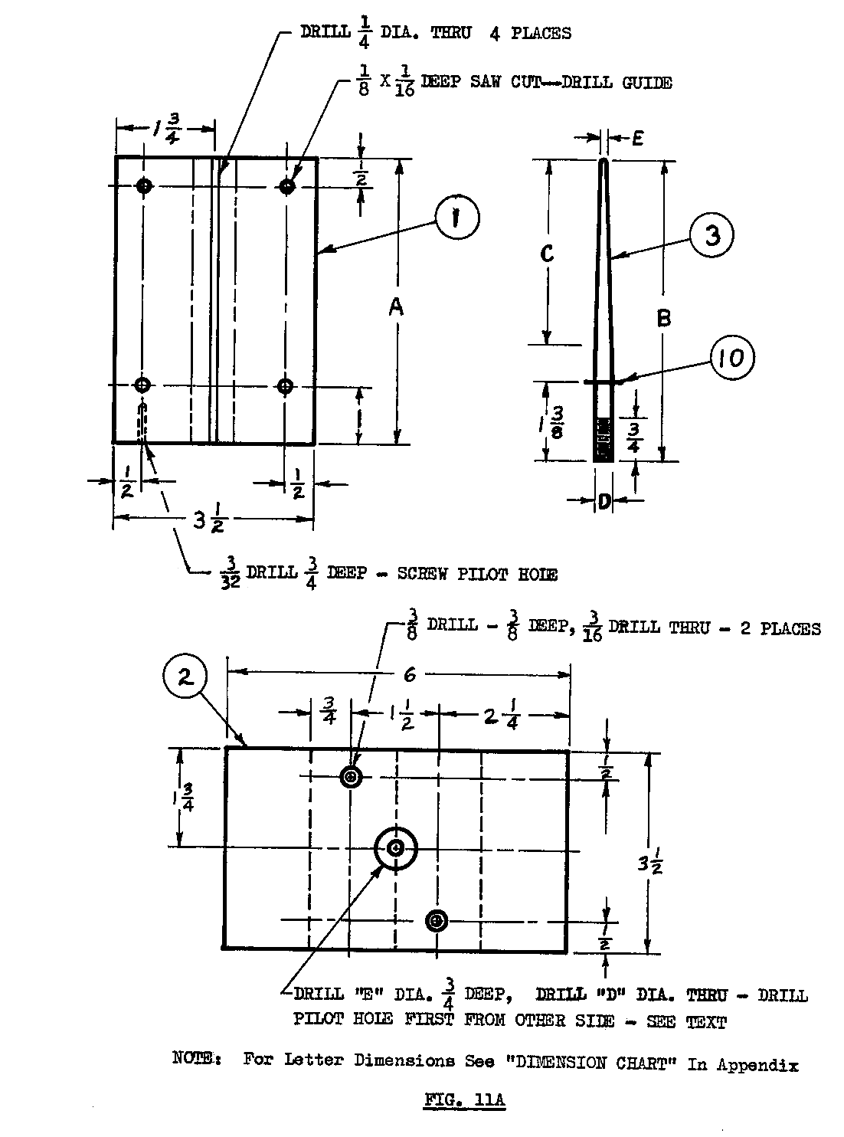
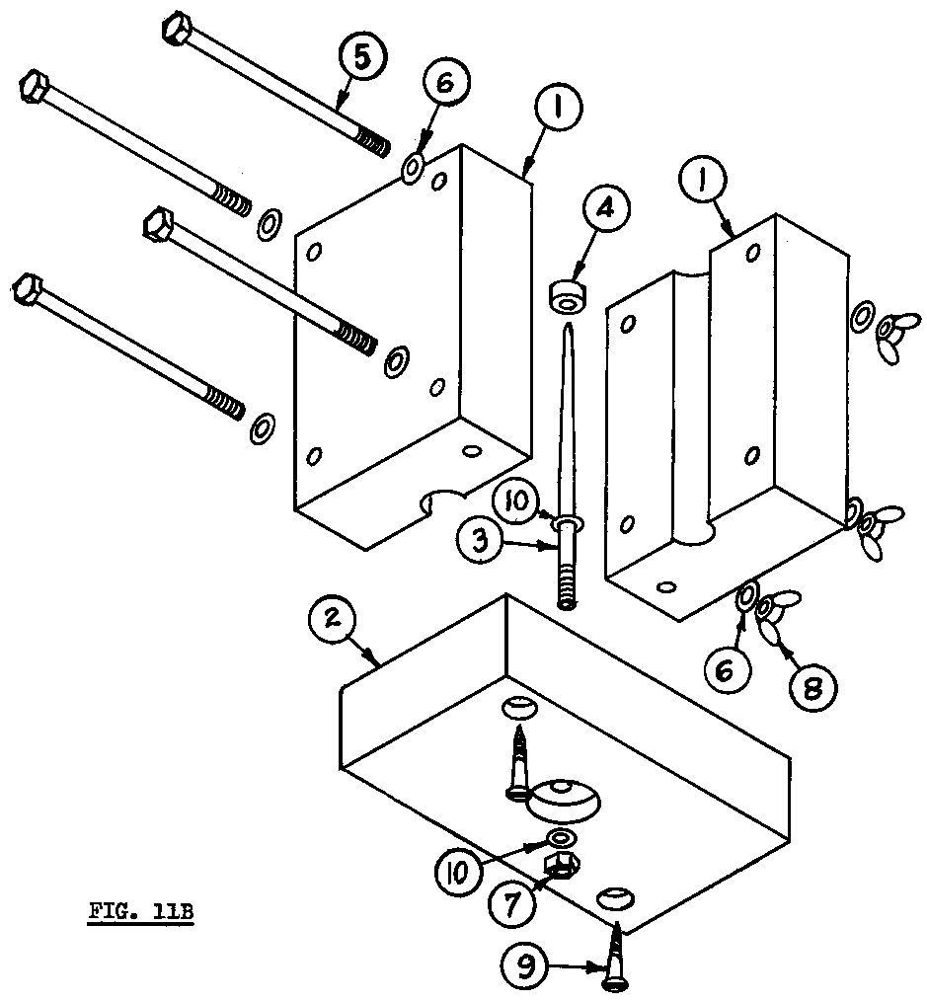
1. 2 X 4 wood "A" inches long -- 2 req'd
2. 2 X 4 wood 6" long
3. Piercer -- "D" inch dia. rod -- "B" inches long
4. Wood dowel -- same dia. as case I.D., half that dia. long
5. ¼" hex head or carriage bold 3½" long -- 4 req'd. *
6. ¼" flat washers -- 4 req'd *
7. "D" inch nut
8. ¼" wing nuts -- 4 req'd.
9. #10 wood screw 1-3/4" long -- 2 req'd.
10. "D" inch flat washer -- 2 req'd.

(See Appendix I for the dimensions for “A”, “B”, and “D”. The dimensions vary with the size of the engine being constructed.

*Note: 1/4" and 3/8" molds require only two bolts (item 5) centered vertically on mold body. 7/8" & 1" require 6 bolts, the extra 2 centered between the bolts shown.

LOADING THE ENGINE

Commercial model rocket engines are compressed into the casing using hydraulic pressure. The home constructed engine is made by compressing the charge with blows from a wood or plastic mallet. This method uses impact to produce a large compressive force. This force is applied only for an instant rather than continuously but the impulse force can actually be much higher than could easily be applied hydraulically. The pressure generated in this way depends on the weight of the mallet, speed at which it is swung, distance the charge is compressed, and surface the mold rests on during loading. If the loading is done, for instance, on a counter top, much of the energy will be absorbed by the counter. If loading is done on a concrete floor the mold itself will absorb some of the energy but a much higher portion of it will go into compressing the powder.
Since very high-pressure impulses are produced with a mallet care must be used to not over compress the propellant. The case can be split even inside the mold body if excessive force is used.
A disadvantage of the impulse compression is that the energy absorbed is dissipated down through the charge. In other words, the top portion of powder is compressed much more than the powder deeper in the case. Because of this small portions are compacted at a time. Ten or more separated charges are separately placed in the case and compressed.
Rub a bar of soap all over the piercer for lubrication and then place a case in the mold and close the mold. The mold should not easily close completely. If the case is loose in the mold wrap enough extra layers of paper around the case so the mold lacks 1/16 inch of closing easily. Wrap an extra paper around the nozzle end of the case two or three wraps. This is where all the mold-split cases originate and so this area needs to be extra tightly compressed in the mold. Tighten the wing nuts to close the mold. Remove the base.
Common pottery ceramic clay is used for the nozzle. The clay should be of the consistency used for sculpting. A block of prepared clay can be purchased at many arts and crafts stores. Keep the clay in an airtight bag or container. A five-pound block would make about 325 nozzles for a 5/8-inch inside diameter rocket. Weigh the amount of clay needed for the nozzle as indicated in the dimension chart. Shape the clay around the base of the piercer small enough that the casing (in the mold body) can be slid down over the piercer, clay and spacer. The casing must fit tightly on the nozzle spacer and the spacer tightly on the piercer. If the spacer is loose on the piercer, it should not be used. If the casing fits loosely on the spacer, wrap cellophane tape around the spacer until the fit is snug. If the fits are not tight, the nozzle clay will be forced out and not enough will be left to form a good nozzle. Use the longest loading dowel to compress the clay until it does not compress any farther. Do not use the mallet--hand pressure only. Screw the base on securely.
Insert each of the two shorter loading dowels and let them slide down the piercer until they stop. Place a mark on the dowel even with the top of the case.
Use a funnel or make one from cardboard to aid in loading the powder charges. Be sure to use moist powder as described before. Weigh out each charge until you can estimate the quantity without weighing it. Pour in the first charge of powder, insert the longest loading dowel and compress the powder with fairly light mallet blows. Eight or ten blows should be given each charge. Load the remainder of the charges in the same manner. Slide on the next smaller loading dowel each time after a charge is compressed. When the line on that dowel is above the case, add the next charge and use that dowel to compress the charge and the following ones until the last dowel is used. When the top of the piercer has been covered by a compressed charge, use the dowel with no hole to compress the last charges. Before the piercer is covered, measure down from the top of the case to the top of the piercer and write down the measurement. Subtract the top loading thickness from this and compress charges until this dimension from the case top to the powder is achieved. The thickness of the top loading can be altered to provide a longer or shorter time delay as needed.
Weigh out the amount of clay for the top heading and lay it in on top of the powder charge. Wrap tape around the blank loading dowel so it fits snuggly into the casing and then compress the clay by tapping the dowel with the mallet several times. Remove the dowel. Poke the shank end of a twist drill bit down through the clay to the compressed powder. Remove it, turn it over and reinsert it in the hole. With your fingers, twist the bit until it just cuts into the powder. Set the engine aside to dry for several days or use a food dehydrator to speed the drying. The clay must have a chance to dry very completely or the hot exhaust gases can vaporize the remaining moisture in the clay and make the nozzle crack or crumble. If the clay heading is not compressed very tightly, it will shrink when dried and must then be removed and glued back in with glue around the outside of it.
After the clay has dried thoroughly make a white glue, or better yet, epoxy fillet all around the nozzle where it joins the case and similarly on the top heading. Allow this to dry completely.
Last, add the prescribed amount of smokeless gunpowder on top of the clay heading. Tap the gunpowder down into the hole in the clay. Glue a piece of paper down on top of this charge and again set aside the engine to dry. When it is dry, it is ready for use.
If you want to try a choked case instead of the clay nozzle replace the flat nozzle spacer with a half ball as described in the casing section. Wrap twine around the choked portion of the case until it is even with the outside. This will help support the tube and prevent it from being crushed during loading. Be sure the casing fits tightly as previously described. Loading is accomplished in the same manner. In place of the clay heading, a section of doweling with a hole drilled in it can be used. It must be firmly glued in place preferably with epoxy. Another possibility would be to use several cardboard discs glued together to build up the proper height and with a hole drilled through it.
The old artificers used the rocket engines for skyrockets and merely attached them to a long stick for the proper balance and stability. After the propellant was loaded, the remaining casing was folded in over the top. (See Figure 3) The paper laminations were separated a few at a time by inserting a thin knife blade into the edge. The paper on the inside was folded down, tapped with a dowel and mallet, rotated and the next section folded down and compressed until the entire top had been folded down over the powder. The top layer was glued in place and then a few holes were made in the folded over casing down into the top powder charge. The holes were made with a sharp awl or drilled. A separate paper container was then attached to the top of the engine containing the expelling charge and fireworks display garnitures.
There are many variations possible in manufacturing the rocket engines. Instead of using a piercer, the core can be drilled out after the case is loaded. The clay nozzle, however, should be formed with the orifice hole in it while the clay is wet so essentially a very short piercer must be used. When drilling the hole, care must be taken not to damage the nozzle. Also, the powder tends to adhere to the twist drill bit and plug it up. Much heat can be generated by drilling and this must be avoided at all costs to prevent ignition of the propellant. Because of this, drilling the core is much more hazardous and is not recommended. If drilling is attempted, the drill bit must be backed out frequently, unplugged and allowed to cool. Drilling should not be attempted on engines with an inside diameter greater than 3/8 inch (3/16 drill bit). The drilled engine core is cylindrical rather than conical so produces a different type of thrust curve depending on the depth of the core.
Different shapes and lengths of piercers, different nozzle diameters, different total engine lengths are all possible parameters to experiment with. Two stage piercers with the lower section larger in diameter with an abrupt change to a smaller diameter with different length proportions is another possibility for experimentation. This type core should give a high initial thrust followed by a lower sustaining thrust.
When experimenting with different configurations, be sure to ignite the engine first in a static test stand from at least twenty feet for inside diameters up to 5/8 inch and considerably farther away for larger engines in case they burst. Point the top and bottom of the engine away from you or any other people or property that could be damaged. If the nozzle or top clay heading should happen to not be secured sufficiently they could be blown out of the casing. Because of this, great care should be taken to roll tight cases and provide a large fillet of glue around the bottom of the nozzle and the top of the top clay heading. Always carry out experiments in seclusion without spectators.
Before using engines in model rockets, test several of the exact type in a static test stand to be sure that they will consistently work properly. It can be very heart breaking to watch many hours of work on a model rocket shattered into confetti when a poorly made engine bursts.
Any diameter engine--smaller, larger, or in between the sizes listed in the dimensions chart (Appendix I) can be made. Also the lengths of the engines can be changed to any desired length as long as the nozzle diameter is changed according to the following formula:

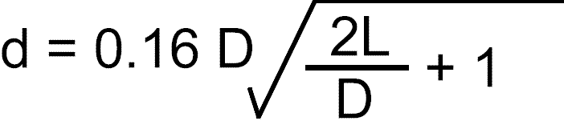

where d is the nozzle diameter, D is the inside case diameter and L is the length of the propellant core. Other dimensions are determined in terms of D as follows:

Outside Case Diameter . . . . . . . . . . . . . . . . . . . . . . . . . . . . . 1.5D
Piercer Tip Diameter . . . . . . . . . . . . . . . . . . . . . . . . . . . . . 0.25D
Propellant Length Above Core . . . . . . . . . . . . . . . . . . . . . 0.375D
Top Heading Thickness . . . . . . . . . . . . . . . . . . . . . . . . . . . 0.75D
Nozzle Thickness . . . . . . . . . . . . . . . . . . . . . . . . . . . . . . . . . 1.25D
Nozzle Spacer Thickness . . . . . . . . . . . . . . . . . . . . . . . . . . . 0.5D
Length Above Top Heading . . . . . . . . . . . . . . . . . . . . . . . . . 0.5D
Total Case Length . . . . . . . . . . . . . . . . . . . . . . . . . . . . . . 2.875D + 0.875”
Decreasing the core length without changing the orifice size will produce a longer thrust duration with a lower thrust. This effect, however, is not proportional because the higher the pressure is, the greater the burn rate is. The dimensions given are for the maximum thrust that will also give the shortest thrust duration. A longer thrust duration and lower thrust is more efficient and more desirable for lighter weight rockets.
The more the powder is compressed, the slower it will burn but the higher the total impulse will be. If the powder is not compressed sufficiently, the clay nozzle also will not be compressed sufficiently to withstand the pressure and it will be blown out.
To help hold the top clay charge in position, a hole 1/4 to 1/2 the I.D. in diameter can be drilled through the casing walls at the mid point of where the clay heading will be. When the clay is compressed, the clay will extrude out the holes and help anchor it in place.
USING THE ENGINES IN ROCKETS

It is assumed that the experimenter has had previous experience with model rockets and so no attempt will be made to provide details of their construction. The major difference between a home made rocket engine and a commercial one when used in a model rocket is the outside dimension. Commercial cardboard tubes can often be obtained from model rocket suppliers that are close enough to the outside diameter of the engine to work sufficiently well. A friction fit is used to hold the engine in place. Masking tape is wrapped around the nozzle end of the engine so that a tight fit is obtained and a five to ten pound force must be used to push the engine into place. If the engine is much smaller than the engine-holder tube tape should be added also to the top of the engine casing so it will not be loose but still slide readily into the tube.
An easier method of obtaining a good fit with commercial tubes is to build up the outside of the rocket engine casing when rolling them so that they will readily fit the available tubes. Never reduce the wall thickness to obtain a match fit. The casings also should have smooth outside surfaces free from wrinkles and should have perfectly round cross sections to fit well in the engine holder tube.
An engine holder tube can be made to any size in the same manner the engine casing was made. The tube, however, would only need to be a few layers thick to be rigid enough. Any cylindrical item such as dowels, plastic pipe, metal rods, etc. can be used as mandrels.
When preparing the rocket for flight, it might also be a good idea to add a little extra flame proof wadding to protect the recovery system.
The most important aspect of building a rocket and preparing it for flight is to check the balance. Remember that the center of gravity must be ahead of the center of pressure for stable flight. The home made engine is somewhat heavier for the same total impulse (power) as an equivalent standard commercially manufactured engine and so rockets may tend to be tail heavy. Either additional weight can be added to the nose or additional fin area can be added to the tail to make the rocket stable. Never use a rocket intended for commercial engines with your home made engine without first checking the stability. Consult the references at the end of the book for texts on model rocketry. There are many that will give detailed instructions on building model rockets.

APPENDIX I
Dimension Chart

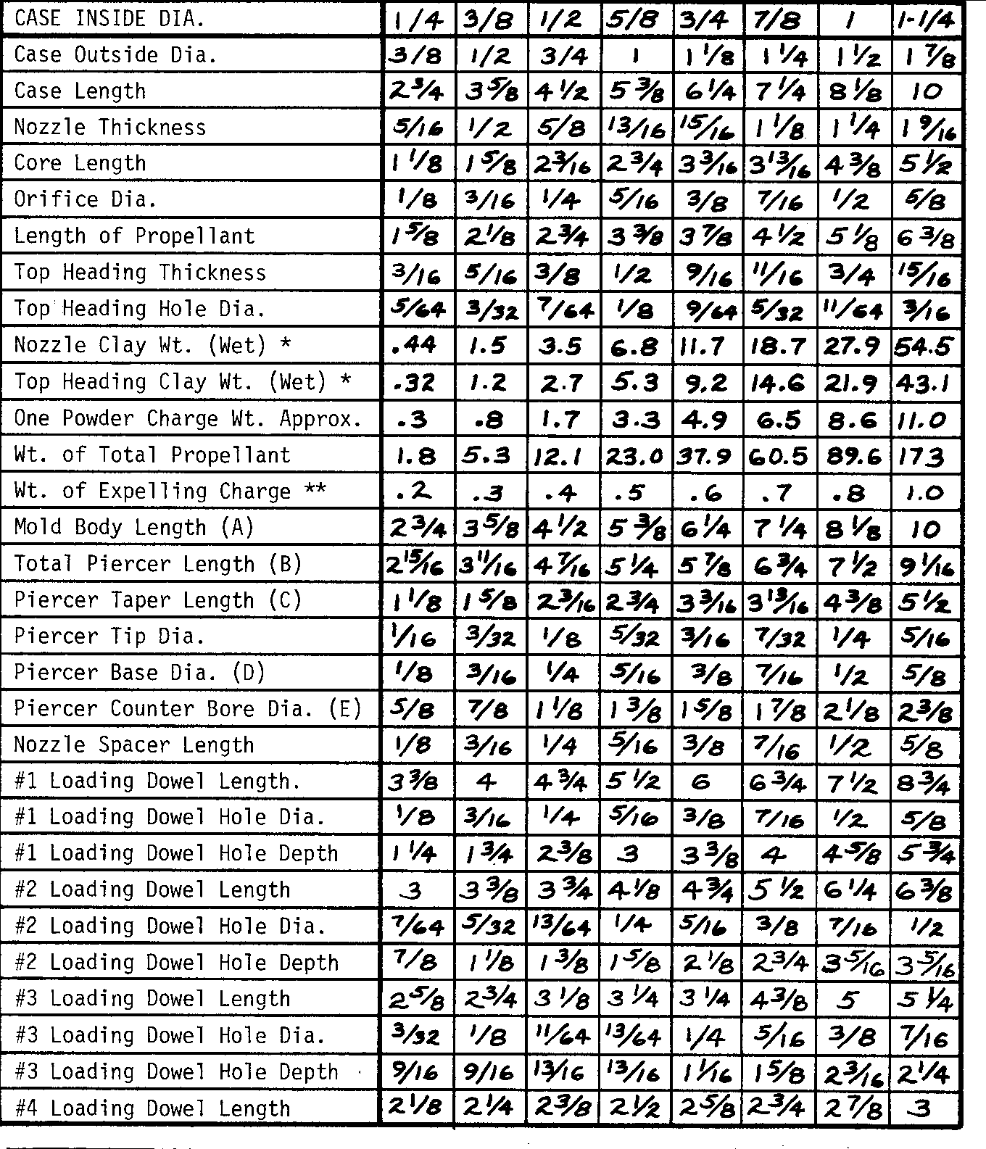
NOTE: All dimensions in inches, weights in grams

* If you drill two holes 3/8" I.D. in dia. to help secure nozzle or top heading, multiply clay weight by 1.08
** Smokeless Shotgun Powder.
APPENDIX II

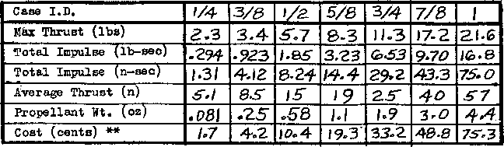

NOTE: The values given in this chart are values obtained from actual tests but values you obtain may vary somewhat due to small dimensional differences and/or propellant densities.
**Prices based on the followiong: sodium silicate $5.85/gal; charcoal $5.00/5 lb; sulfur $4.50/5 lb; potassium nitrate $8.30/5 lb; bentonite clay $4.65/5 lb; calcium carbonate $4.00/5 lb; 1125 ft roll of 50# kraft paper $26 (0.77¢/ft2)

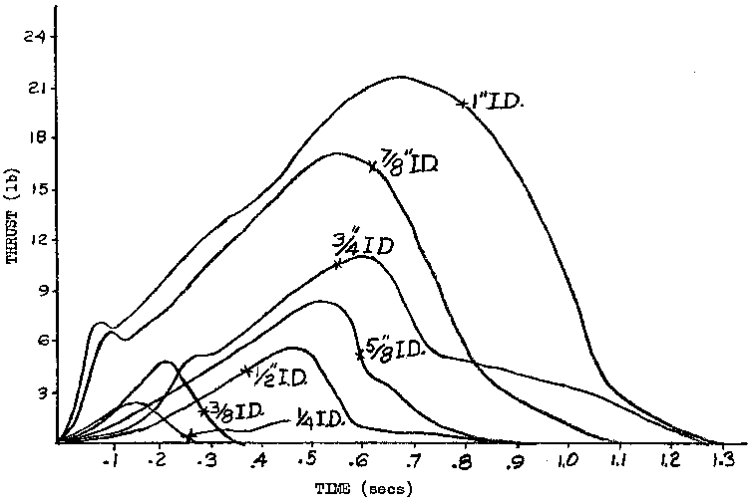

Examples of thrust-time curves from actual tested engines.

revised Dec. 1979

APPENDIX III

Homemade Balance
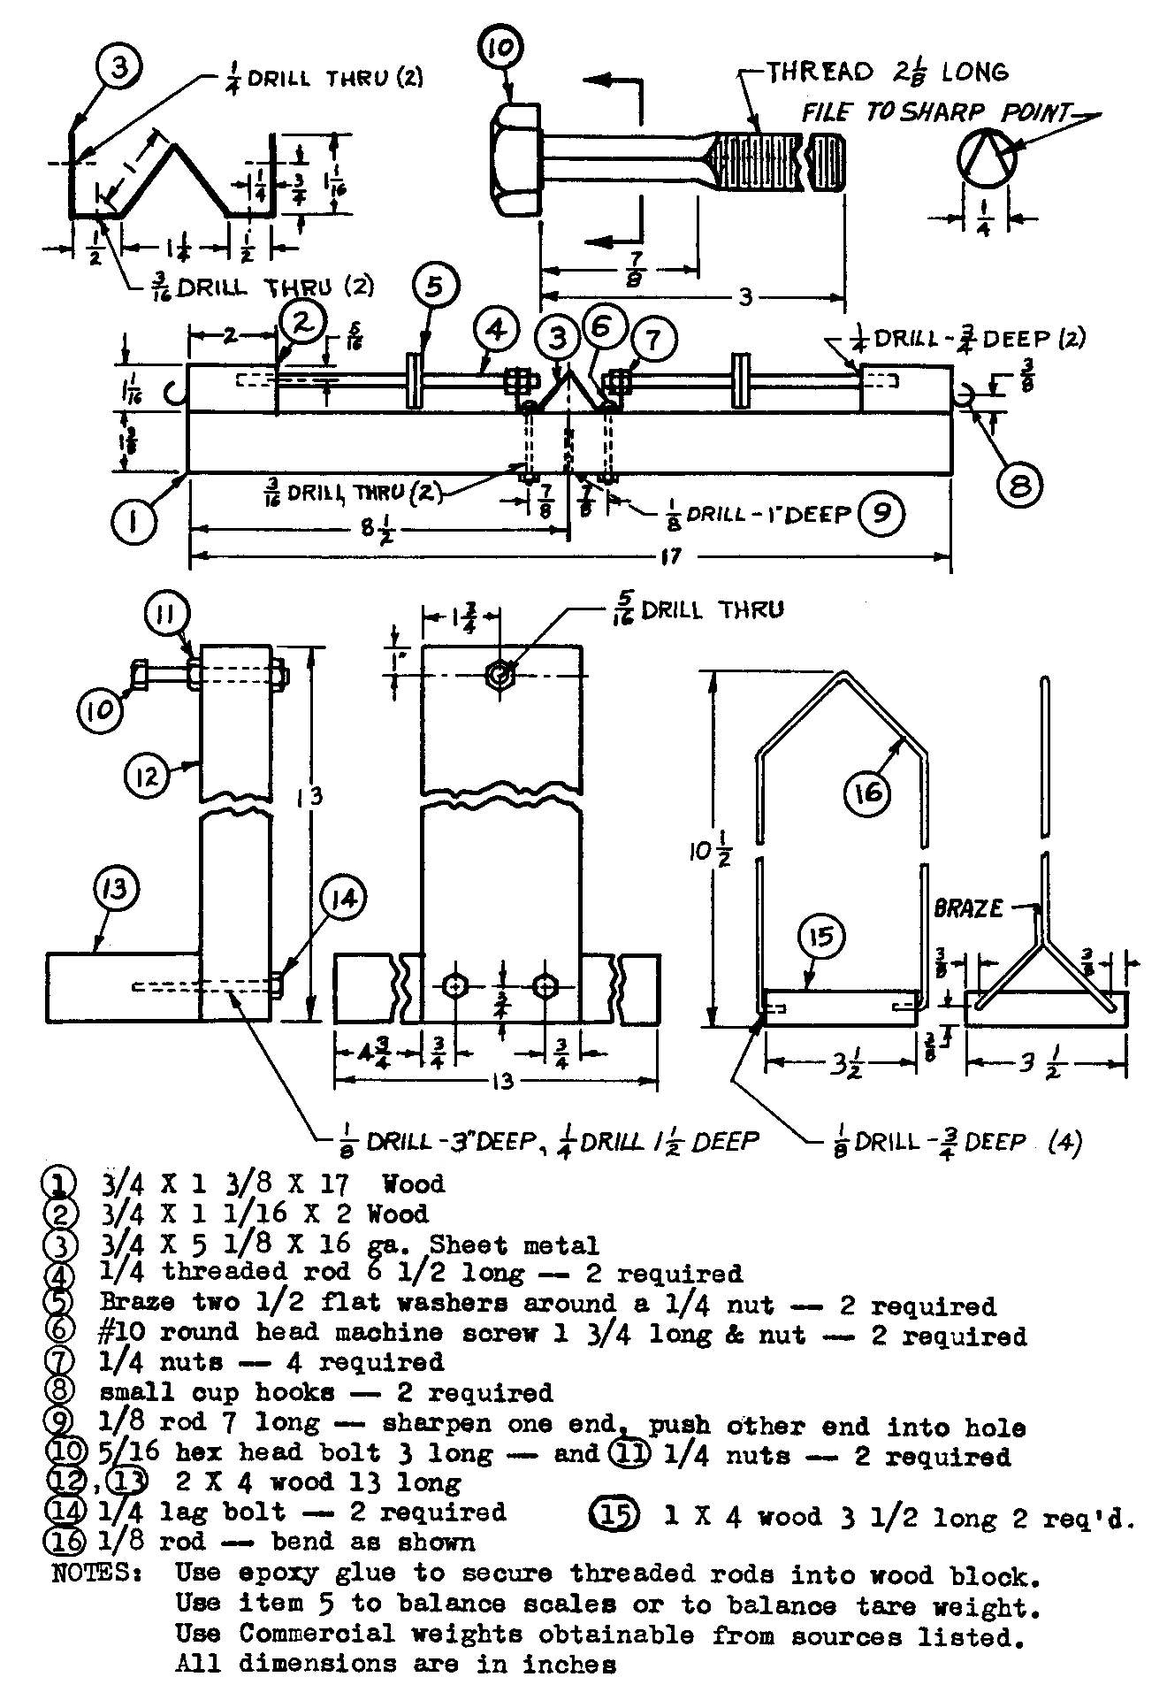

APPENDIX IV
TROUBLE SHOOTING HINTS

I. CASE SPLITS IN MOLD
- Case too dry when loaded or case rolled too loose.
- Case fits too loosely in mold. Make sure the mold must be forced to close on the case. Check especially the nozzle end and wrap two or three extra layers of paper about three diameters (I.O.) wide around the nozzle end of the case.
- Flared bore at nozzle end of mold. Often when drilling, sanding, or trimming the bored hole in the mold body, the diameter at the nozzle end will be inadvertently increased more than the rest of the body. This will allow the nozzle end of the case to expand and split while loading even though the rest of the case is snug.
- Excessive force used to compress powder. As was explained in the loading section, the impulse force generated by impact of a mallet can be extremely high. Let the weight of the mallet do most of the work. Fairly light blows will do the job quite well. Only experience can give you the feel for how much force to use loading the engines. The nozzle clay and the first two or three powder charges should have less force used to compress them since the following charges will also compress them farther.

II. CASE BURSTS WHEN ENGINE IS FIRED
- Insufficient force used to compress powder.
- Weak case caused by too thin glue, poor quality paper, or loose rolling. Loose rolled cases can cause inside layers to split with no outside evidence of it. Cases should be hard and rigid.
- Voids in powder. Air pockets in the propellant increase the burning area and so increase the internal pressure. Air pockets are usually a result of trying to compress too large a charge at one time. Wrinkles or other irregularities on the inside surface of the case can also cause voids by stopping the loading dowel.
- Propellant too powerful. Use only charcoal sulfur and potassium nitrate (saltpeter). Any substitutions will change the effect of the powder. Never use chlorates or perchlorates in the mixture. Do not use commercial black powder or smokeless powder as these are much too powerful and can explode rather than burn progressively.
If experimenting with new engines, the nozzle diameter may be too small or the core too long. Either of these conditions will cause excessive internal pressure. If the standard engines continually burst, the cases may be weaker than usual and it may be necessary to decrease the core length, increase the nozzle diameter, or increase the case wall thickness. Increasing the case wall thickness is the least desirable because this requires more wraps of paper and increases the difficulty in rolling tight cases. For the same reason, the larger engines are more difficult to build properly and people more frequently have trouble with bursting cases and ejected nozzles and top clay headings in these engines. There should be little problem with engines up through 5/8 inch I.D.

III. INSUFFICIENT THRUST DEVELOPED
- Propellant too weak. If the ingredients and methods of preparation explained in this book are followed precisely, there should be no problem. All the components must be a very fine mesh, especially the sulfur and charcoal. A minimum of 125 mesh and preferably 325 mesh should be used. Insufficient mixing can reduce the power of the powder also. The powder must be mixed thoroughly with the prescribed amount of water. Mechanical mixing without water will in no way produce acceptable powder. The powder must be loaded moist to compress properly.
- Insufficient force used in compressing the powder will decrease the total amount of powder in the engine and so decrease the amount of powder available to produce thrust. This will normally occur only in small engines. In larger engines, the case will usually burst due to increased burn rate.
- In experimental engines too large a nozzle diameter or too short a core will result in insufficient thrust.

IV. PULSATING THRUST
- Engine and propellant not completely dry.
- Too large powder charges can cause irregularities in the propellant that can cause non-uniform burning.
- Insufficient force or varied force used in compressing the charges can cause non-uniform propellant.
- Impurities, foreign particles (such as sawdust or metal filings) or insufficient propellant mixing can cause non-uniform propellant.

V. NOZZLE EXPELLED
1. Insufficient force used to compress charge.
2. Case too dry when loaded preventing proper seating of clay nozzle.
3. Check glue fillet. Use epoxy if you are having problems.
- Poor quality case. A properly rolled and glued case will be a solid tube and the layers of paper cannot be separated from each other without being cut. The nozzle cannot be expelled without taking a chunk of the case with it and the case will usually burst before this happens. If the case is not rolled and glued properly, only one layer of paper must be torn free to expell the nozzle and this will happen every time. The usual problem is the glue was too thin to properly adhere the layers of paper to each other.
- Wet clay. If the clay is not thoroughly dry, the clay can be easily sheared and will usually be destroyed. Also the high temperature exhaust gases will vaporize the moisture in the nozzle and cause the nozzle to actually explode.
- Nozzle too short. If the nozzle spacer is not tight, clay will be forced out around it and not enough will be left to form the necessary length of nozzle. Some will be forced out anyway and this must be cleaned off down to the paper casing so the glue adheres to the case.
- If the nozzle is too small or core too long, the nozzle and/or top clay heading may be expelled before the case bursts.

VI. TOP CLAY HEADING EXPELLED
All the problems causing the nozzle to be expelled also apply to the clay heading. Usually the clay heading will go first because it is not compressed near as much as the nozzle. It can also shrink when it is dried where the nozzle being compressed more won't. This leaves the entire load on the adhesive strength of the glue fillet, which is not sufficient. The clay heading must either be compressed sufficiently to not shrink or else it must be removed and have glue applied around its sides in addition to the glue fillet. One last possibility might be to fold over and glue several of the layers of paper above the clay and then drill through it down to the propellant when the glue is dry, or drill holes as described at the end of the “loading the engine” section.

VII. EJECTION CHARGE NOT IGNITED

- Hole in the clay heading not extended to propellant. When making the hole with a drill bit, some of the powder should remain on the bit when it is removed if it is actually down into the powder. The powder is very hard in comparison to the soft clay so there should be no problem in telling when you have reached it.
- Clay heading hole plugged. Any material such as clay particles in the hole will prevent the flame from traveling to the ejection charge.
- Empty clay heading hole. The hole should be filled either with propellant or ejection charge particles. If the later is used, it should be ground or crushed small enough to fit easily into the hole. Tamp it in with a drill bit shank. Do not crush the ejection charge itself. Dump out the excess crushed ejection charge.

REFERENCES

BOOKS AND PUBLICATIONS

Stine, G. Harry, Handbook of Model Rocketry. Chicago, Follett Publishing Company, 1976
Lowry, Peter, and Griffith, Field, Model Rocketry, Hobby of Tomorrow. Garden City, New York, Doubleday and Company, Inc., 1971
Mandell, Gordon K. et al., Topics in Advanced Model Rocketry. Cambridge, Massachusetts, and London, England, The MIT Press, 1973
Boyd, Grant, Design Manual, Phoenix, Arizona, Centuri Engineering Company, 1968
Barrowman, Jim, Stability of a Model Rocket in Flight, Technical Information Report TIR-30, Phoenix, Arizona, Centuri Engineering Company, 1968
Barrowman, Jim, Calculating the Center of Pressure, Technical Information
Report TIR-33, Phoenix, Arizona, Centuri Engineering Company, 1968
Gregorek, Dr. Gerald M., Aerodynamic Drag of Model Rockets, Technical Report TR-ll, Penrose, Colorado, Estes Industries, Inc., 1970
Brown, Edwin D., Model Rocket Engine Performance, Technical Note TN-2, Penrose, Colorado, Estes Industries, Inc., 1971
Hajek, Stanley M., and Schutte, Raymond L., Space Age Technology, Penrose, Colorado, Estes Industries, Inc., 1970
Faber, Henry B., Military Pyrotechnics-The History and Development of Military Pyrotechnics. Volumes 1 and 2, Washington, D.C., Government Printing Office, 1917
Davis, Tenney L., The Chemistry of Powder and Explosives, Hollywood, California, Angriff Press, 1943

MODEL ROCKETRY SUPPLIES

Aeronautics and Space Company, 401 Wayside Court, Nashville, Tennessee 64133
AVI, Astroport, Mineral Point, Wisconsin 53565
Centuri Engineering Company, Box 1988, Phoenix, Arizona 85001
Competition Model Rockets, Box 7022, Alexandria, Virginia 22807
Estes Industries, Inc., Box 227, Penrose, Colorado 81240
Flight Systems, Inc., 9300 East 68th Street, Ray town, Missouri 64133
"Kopter", P. O. Box 98226, Pittsburg, Pennsylvania 15203

CHEMICALS AND LABORATORY SUPPLIES

Starr Scientific, 916 Madison Street, Manitowoc, Wisconsin 54220, Catalog $1.00
Merrell Scientific, 1665 Buffalo Road, Rochester, N.Y. 14624, Catalog $2.00
Pioneer Industries, 14a Hughey Street, Nashua, N.H. 03060, Catalog $1.00
K/N Chemical Co., Box 748, San Bernadino, CA 92402, Catalog 50~ Deluxe Scientific, 507 Huron, Manitowoc, WI 54220, catalog $1.00

REVISED TECHNIQUES

Development of rocket engines is being carried out continually by PEADCO and the new information gained to this point is included here.
Solid propellant engines—even commercial model engines and large engines—are not as predictable as liquid fueled engines. Liquid fuel is pumped at a specific controlled rate. Once a solid propellant engine is ignited, there is no control over the consumption of fuel and any slight disturbance or inconsistency in the propellant grain or flame within the engine can totally change the thrust-time curve. Homemade engines with nearly identical propellant densities have been tested over and over and have yielded specific impulses as low as 40 seconds and as high as 70 seconds with about 90% falling between 50 and 60 seconds.
You might be surprised to learn that commercial core burning model rocket engines are not much more consistent than this and that your homemade engines will perform very satisfactory in your models.

CASES
A different adhesive has been found that makes rolling cases easier and the completed case is rock hard, strong and fire resistant. This chemical is sodium silicate commonly called water glass. Use the liquid as is with no thinning. Thinning with even a small amount of water has been found to decrease the strength of the case. Let the cases dry in a warm dry place for two or three days or dry them at a low setting in a dehydrator. Too much heat in the drying process often causes the cases to sag causing an oval cross section. To eliminate this, dry them standing on end. Dry the cases 100% before loading and keep them dry by storing them in a plastic bag. All ingredients used in the engine should be stored in airtight containers to keep them dry.
Since the cases are now loaded dry, they should be rolled with an outside diameter that will just slide down into the mold body after been bolted together. It should not be compressed onto the case as described in the manual.

MOLDS
The only reason for the mold body now is to maintain the piercer in the exact center of the case. The mold body can actually be shortened, made in one piece, made in two pieces and glued together or eliminated entirely if care is used to keep the case centered. The spacer should be shortened to be only thick enough to just fit inside the case to center it around the piercer. Well made loading dowels (drifts) will also help keep the piercer in the exact center of the case. Center the piercer tip in the center of the case as you load it. In the early stages of loading, if the piercer becomes off center, pushing on the case while compressing the charges will move it slightly. Once the case is about a quarter or third loaded, the case will stay in position.

PROPELLANT
Use a mixture of 75% potassium nitrate, 15% air-floated charcoal powder and 10% sulfur. The most inexpensive and best quality supplies can be obtained from the sources listed at the end. The 75-15-10 mixture is too fast burning by itself for the engine dimensions listed in Appendix I so it is used for a base and slowed by the addition of a small percentage of calcium carbonate. Dry the powder and then mix dry l½% calcium carbonate with 98½% of the dry propellant. Powder and mix them together thoroughly in a mortar and pestle or sift them through a fine mesh screen if there are no lumps. To more accurately measure the l½% calcium carbonate, first make a thorough mixture of 15% calcium carbonate and 85% powder. Then mix 10% of this with 90% powder. Whether this second procedure is used or not will depend on the accuracy of your balance and the total amount mixed. A large amount can be weighed more accurately than a small amount.
The reason the calcium carbonate is used instead of making the engine the proper dimensions to start with is so that if the engine-size/fuel-ratio is not the most efficient a different fuel mixture can be easily and quickly made rather than making an entirely new mold each time.
The propellant is loaded dry into the casing and the engine can be used immediately since none of the components need to be dried now.

COMPRESSING POWDER CHARGE .
It has been found that compressing the propellant more does not increase the specific impulse of the fuel. What does increase the specific impulse is increasing the internal pressure and exhaust velocity and so thrust for a given nozzle diameter. Compressing the propellant more does increase the efficiency of the engine in that more fuel is used in the same casing and so more total impulse is obtained for the same engine and the total impulse for a total given engine weight increases. The more the propellant is compressed the, slower it burns and so less calcium carbonate is added to obtain the desired thrust. For example, two half inch I.D. engines were tested. Both contained the exact same volume of propellant but one was compressed to contain 12.7 grams. It required 6% calcium carbonate to slow it and yielded a total impulse of 1.68 lb-sec. The second was compressed to hold 17.2 grams and required only l½% calcium carbonate to slow it and yielded a total impulse of 2.53 lb-sec. This corresponded to specific impulses of 61 and 67 seconds.
To obtain good-results using the propellant described, the exact length of the propellant from nozzle to delay charge must be measured and the exact amount of propellant specified should be weighed out. When the exact height is reached, the amount of propellant left over should not be more than about 10% of the total or it becomes likely the engine will blow up. The engine casing I.D. must also be accurate. Use l½ wraps of 4-mil plastic around the rolling dowel for a spacer. This will give a .02 to .03 oversize I.D. (.012” in theory but in practice the paper cannot be wrapped by hand perfectly tight) for an easy loading dowel fit. This distance can be determined by marking a line even with the top of the case on the loading dowel resting on the nozzle, and then on the propellant charge and measuring between them.

CLAY NOZZLE AND TOP HEADING
Moist ceramic clay shrinks when dried and has never worked well. The problem with nozzles and top headings has been completely eliminated by using dry clay. There are many different types of clay and some work better than others. The dry clay that is used to make slip for poured ceramic pieces does not work well. 200-mesh bentonite clay is preferred by the author. Attapulgus fire clay also works well and there are probably many others that work well too. The clay should form a hard dense mass that does not crumble or flake easily once it is properly compressed in the casing. It is loaded dry and compressed in two or three charges exactly like the propellant. Whenever changing from one material to another in the course of loading the case, the excess loose powder should be shaken out before loading the next substance. This should be done between the nozzle and propellant, propellant and delay, delay and top heading and after the top heading is drilled before the ejection charge is added.
The top heading can be decreased to .50 I.D. if desired when the delay charge is 3/8" thick or more. When a booster engine is made with no time delay, the top heading should be increased to 1.0 I.D. To increase efficiency a 15º expansion cone should be formed at the exit of the nozzle as shown in the cross section below. This can be done simply with a knife. This cannot be done properly with a long section of casing beyond the end of the nozzle, which is another good reason for shortening the spacer.

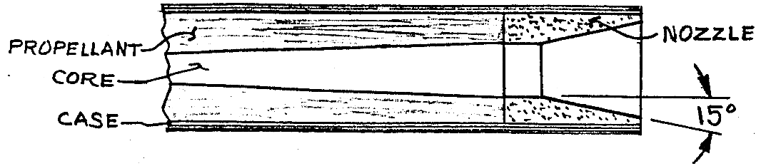
TIME DELAY
Instead of drilling the hole in the center of the top heading, drill it on the edge next to the case. This prevents premature ignition of the ejection charge and allows for a longer and more consistent time delay. Use smokeless powder to fill the vent hole so that the time delay will be provided entirely by the powder below the top heading. In ½" dia. and all larger engines, drill only a 13/16” dia. hole in the top heading. A larger hole is unnecessary and only requires excessive ejection charge to fill it.
The same technique used for slowing the propellant can be used to provide a slower burning time delay. Use one part calcium carbonate and six parts dry 75-15-10 mix (powder) prepared as described for the modified powder. Load propellant to a depth of exactly 3/8 I.D. above the top of the piercer. The delay mixture is loaded above this before the top heading. It burns at a rate of .072 inches per second so for a 5 second delay, the delay mix should be about 3/8" thick when compressed. If the top heading hole is bored into the delay charge instead of just to it or if the propellant thickness above the piercer is too short, the delay will be decreased.
One trick is to mark the exact location of the top of the powder charge (3/8 I.D. above the piercer tip) on the outside of the case and then the exact location of the desired delay thickness above this. Then fill the delay mixture 1/16" or more beyond this point. Load the top heading. Now position the drill bit for the top heading vent on the outside of the case with the tip even with the second mark on the case and put a mark or piece of tape on the drill bit even with the top of the case. Drill through the top heading into the delay charge and stop when it is just even with the top of the case.
The accuracy of the time delay will be directly related to the care used in loading the propellant and delay mixture but will also be affected by the fact that the delay charge must burn diagonally from the center to the outside where the top heading vent is located. Also the internal pressure and burning rate and characteristics may make a small difference in when the delay charge begins burning. As with the propellant, the density to which the delay is compacted (it should be the same as the propellant) will make a difference in the burn rate. Commercial engine delays have an accuracy of ±10% and using these techniques, your time delays will be well within this accuracy too.

STANDARD DIAMETER ENGINES TO REPLACE COMMERCIAL ENGINES
Standard series engines (A, B, C sizes) are 2.75" long and .69" dia. The ½” I.D. engine listed in the manual has a .75" O.D. but this can be reduced to .69" dia. with no problems as long as the cases are rolled tightly. A cardboard engine holder tube can be used to check the fit when the cases are rolled.
Nearly all standard series engines are port or end burning engines. All engines in this manual are core burning. There are severe problems involved in attempting homemade end burning engines (which we expect to have solved within the next year) and so it is not possible to duplicate the total power of a commercial engine in the 2.75" length. A 2.75" long home built engine would be equivalent to an A size but would require a smaller nozzle orifice. A longer engine can be used in a modified rocket by using a longer engine holder and moving the thrust ring forward. A shorter ½” I.D. engine can be made using no calcium carbonate by reducing the core length from 3" to 1-3/4". Specifications for this engine are:
case length 3-3/4"
propellant length 1-15/16"
propellant weight .37 oz (10.5 gram)
total impulse 1.17 lb-sec (5.23 n-sec)
maximum thrust 3 lb.

DIMENSION AND QUANTITY CHANGES
Due to the changes in procedure some of the values given in Appendix I will be changed. Top heading clay weight is not critical. The nozzle thickness is critical rather than the weight but the weight will be given as an aid. The top of the spacer to the tip of the piercer must exactly equal the core length plus nozzle length. This length will be 7.25 I.D. The total piercer length will decrease by the amount the spacer is reduced and can be found by using the formula C + 1-3/8" + spacer length. The changes in the formulas on page 30 will be: propellant length above core .375D, total case length 3.5D + L. Additional changes are given below.
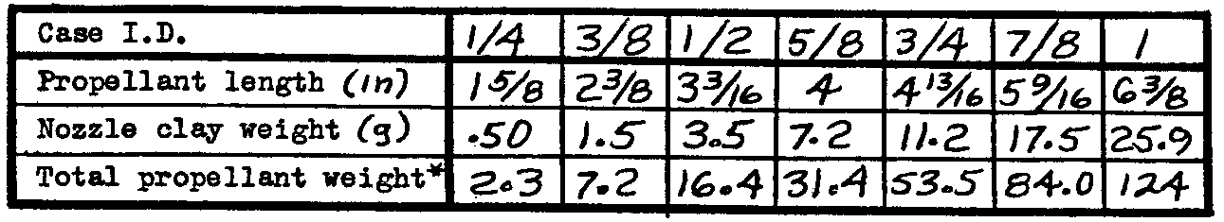
* grams

ADDITIONAL CHEMICAL SUPPLIERS

Chempac Supply Co.  912 Crescent St.  Brocton, Mass. 02402  Catalog $1 | E. D. Cemco, Co.  64 Cottonwood lane  Westbury, N.Y. 11590  Catalog 50¢

